Safe from Harm Reporting
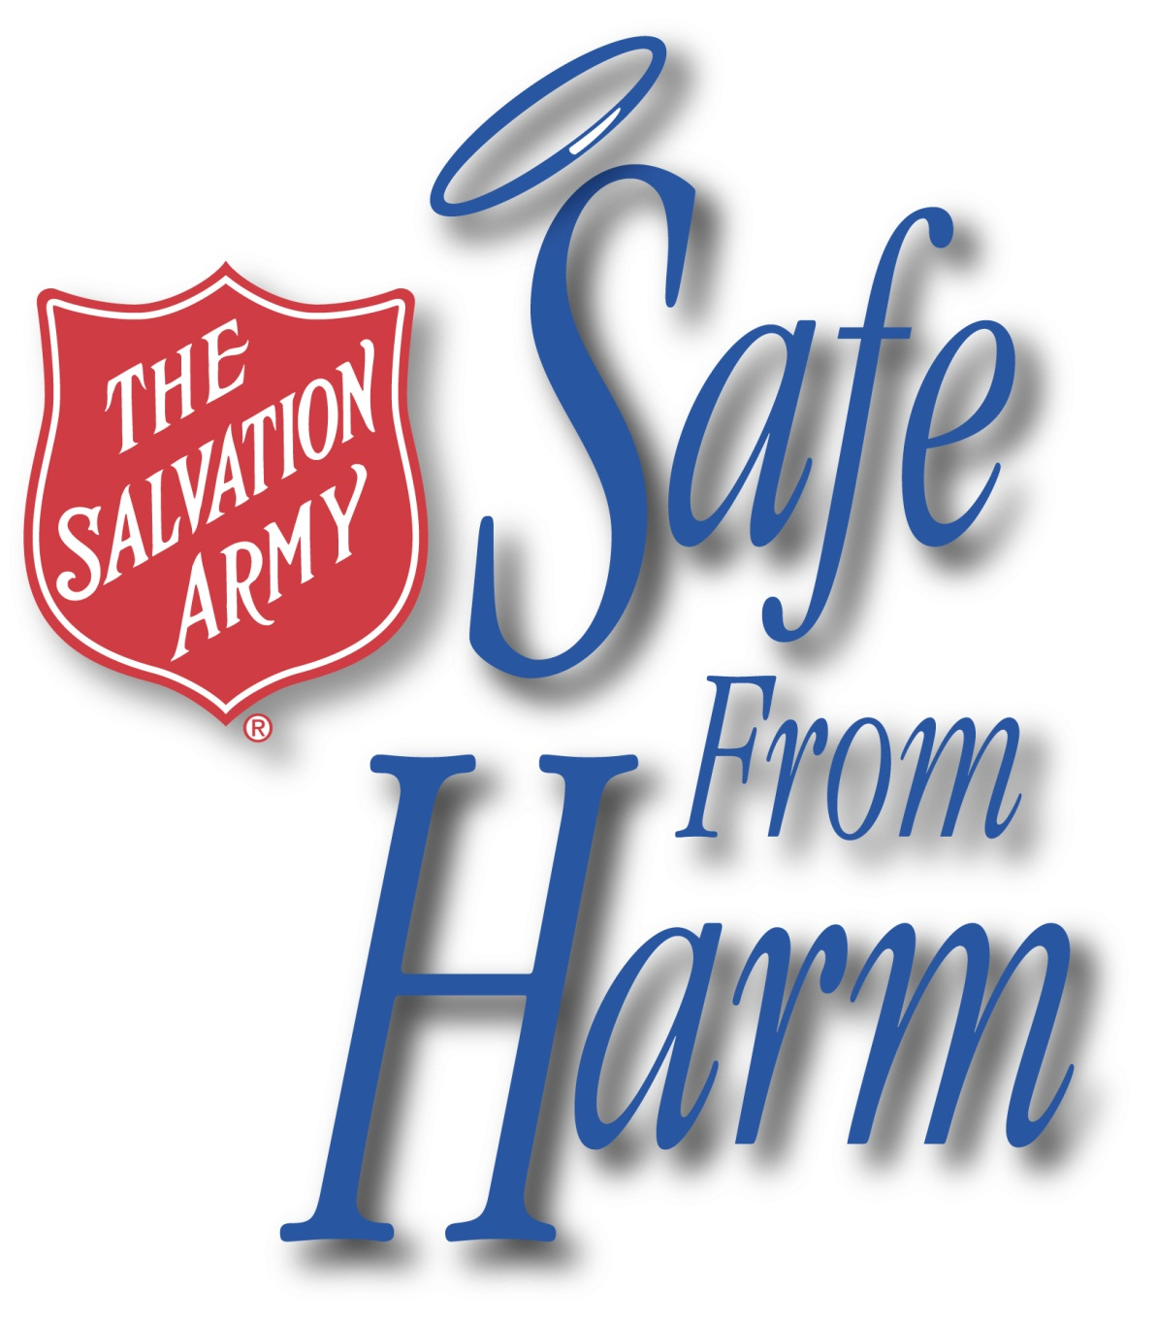
Welcome to The Salvation Army USA Central Territory’s
Safe From Harm Reporting Website.
The following online form was created for The Salvation Army USA Central Territory's Safe From Harm program, a unique safety program that is geared to protect children, vulnerable adults, and Salvation Army personnel throughout the Central Territory's programs and ministry units. The form is intended for personnel and participants to document reporting of the following:

- Suspected or Known Abuse, Neglect, or Exploitation of a Vulnerable Individual
- Concerns of Inappropriate Behavior or Policy Violations Involving a Vulnerable Individual
- Injury of a Vulnerable Individual
- Lost or Missing Vulnerable Individual

All reports should be kept confidential, shared only with those who require direct involvement in the incident or concern for the purpose of upholding Salvation Army National and Central Territory policies as well as United States laws and the laws of states included within The Salvation Army Central Territory.

Communication via the Safe From Harm Reporting Hotline and reports submitted to the Safe From Harm Reporting Website are received by The Salvation Army USA Central Territory Legal Department in a manner that promotes protection by attorney-client privilege.

For more information about who should report, what should be reported, and how to report, please see:
The Salvation Army USA Central Territory Safe From Harm Reporting Book 1
Reporting Incidents & Concerns Involving Vulnerable Individuals: Definitions, Policies, and Procedures

For more information about Salvation Army policies that apply to the Safe From Harm program, please see:
The Salvation Army USA Central Territory Safe From Harm Reporting Book 2
Related Policies and Guidelines Applicable to Safe From Harm Implementation

If you have any questions about reporting or require assistance with reporting, please call the toll-free
Safe From Harm Reporting Hotline to consult with Legal Counsel: 1-855-846-3330

For Incidents/Concerns/Reports please contact the Safe From Harm Reporting Hotline: 1-855-846-3330
For General Safe From Harm inquiries, contact the The Salvation Army USA Central Territory Safe From Harm Program Director: 847-294-2388

Upon completion of the Safe From Harm Incident Reporting Form, please submit to:

SFH_Legal@usc.salvationarmy.org

Subject: SFH Online Report

Safe From Harm Incident Reporting Form
Please complete & submit the following form with as much information as you have at the time,
stating the facts as personally known to you.

Mark all that best describe your reason for reporting:

To the best of my knowledge, I suspect abuse, neglect, or exploitation of a vulnerable individual.

I have directly witnessed what I believe constitutes abuse, neglect, or exploitation of a vulnerable individual.

A vulnerable individual has disclosed his/her experience of abuse, neglect, or exploitation to me.

A vulnerable individual incurred a substantial pain injury on Salvation Army property and/or at a Salvation Army sponsored event.

A vulnerable individual went lost or missing at a Salvation Army sponsored event and/or while in the care of The Salvation Army.

I have observed what I believe to be inappropriate behaviors with/towards a vulnerable individual and/or a perceived blatant Safe From Harm policy violation

Other

Today’s Date

Your Contact Information

Reporting Person’s Name
 | First | Last

Position (within The Salvation Army or otherwise)

Division/Command Affiliation (as known & applicable)

Salvation Army location in which you work, volunteer, or serve (as applicable)

Immediate Supervisor Name at The Salvation Army location in which you work, volunteer, or serve:

Email

Phone number

Mobile Phone

City & State of Address

Reporting Location

Location from which you are making this report

Reporting location contact information same as above |  | Yes

If different, please provide reporting location information, as known, below:

Phone |  | Address

Suspected or Witnessed Incident or Concern

Please report as much information as you have at this time,

stating the facts as personally known to you.

Date of Incident/Concern

Approximate Time of Incident/Concern |  | A.M. | P.M.

Did the suspected or witnessed incident or concern occur on a Salvation Army premises and/or during transportation services provided by The Salvation Army, and/or during a Salvation Army sponsored event?

 | Yes |  | No

Location Name of where the suspected/witnessed Incident/Concern took place
Address of where the suspected/witnessed Incident/Concern took place

Alleged Victim, Injured, or Missing Person: Vulnerable Individual’s Information

Privacy of Victim/Injured/Missing Person: |  |  | By law, partnership or licensing agreement, unable to disclose this information without consent.

Name of Victim/Injured/Missing Person
 | First | Last

Gender | Female | Male

Age

Phone number

Mobile Phone

Address

Email

Position (within The Salvation Army or otherwise)

Parent / Legal Guardian Information

Privacy of Parent/Guardian |  |  | By law, partnership or licensing agreement, unable to disclose this information without consent.

Name of Parent/Guardian
 | First | Last

Phone number

Mobile Phone

Address

Email

Address Same as Alleged Victim/Injured/Missing Person |  |  | Yes

Alleged Perpetrator Information (if applicable)

Privacy of Alleged Perpertrator |  |  | By law, partnership or licensing agreement, unable to disclose this information without consent.

Name of Alleged Perpetrator
 | First | Last

Age

Alleged Perpetrator is a minor (under 18 yrs of age) |  |  | Yes, alleged perpetrator is a minor.

Gender | Female | Male

Phone number

Mobile Phone

Email

Address same as Parent/Legal Guardian |  | Yes, same address as Parent/Legal Guardian

Address

Position (within The Salvation Army or otherwise)

Description of the Suspected/Witnessed Incident/Concern:
Please describe the facts as personally known or witnessed by you.

Were Salvation Army Personnel (officer, employee, volunteer) directly involved in any way?

 | Yes |  | No

If yes, how were Salvation Army Personnel directly involved? (Mark all that apply)

Alleged Victim, Injured, or Missing Person | Alleged Perpetrator | Witness
Other

Please list Salvation Army Personnel involved and describe their involvement

Additional Remarks:

Individuals / Agencies Notified: (Mark all that apply)

No one at this time

Police Date notified

Child Protective Services agency Date notified

Adult Protective Services agency Date notified
Individuals / Agencies Notified (cont):

Parent(s) / Guardian(s) of
Alleged Victim, Injured, or Missing Person Date notified

Parent(s) / Guardian(s) of
Alleged Perpetrator, if a minor Date notified

The Salvation Army Safe From Harm
Reporting Hotline 1-855-846-3330 Date notified

Chesterfield to file an insurance claim Date notified
1-800-743-4311
(Vulnerable individual injury reports only)

Salvation Army Personnel
Please list all, including name, position (officers, employees, volunteers), and date notified

Other individuals I have personally notified

Please list all, including name, relationship to you, relationship to alleged victim, and date notified

Others to my knowledge who I have not personally notified but may be aware of the incident/concern

Please list all, including name, relationship to you, and relationship to alleged victim

Action Taken & Follow Up Plan
If applicable, please describe any action taken and/or any determined follow-up plan that pertains to the suspected/witnessed incident/concern

Upon completion of the Safe From Harm Incident Reporting Form, please submit to:

SFH_Legal@usc.salvationarmy.org

Subject: SFH Online Report

Thank you for your submission of a Safe From Harm Legal Report to The Salvation Army USA Central Territory Headquarters Legal Department. Appropriate action will be taken by The Salvation Army Central Territory Headquarters Legal Department and the Safe From Harm Program Director. Please be aware that you may be contacted for follow up information at any time.
All communication and information shared via this Safe From Harm Website and the Safe From Harm Legal Hotline is received by The Salvation Army Central Territory Legal Department in a manner that promotes protection by attorney-client privilege and is shared only with those who require direct involvement in the incident or concern for the purpose of upholding Salvation Army National and Central Territory policies as well as United States laws and the laws of states included within
The Salvation Army Central Territory.

Thank you for your commitment to keeping all involved in
The Salvation Army safe from harm.

