FRIDAY - MARCH 11, 2022  3:00-7:30 PM Registration Auditorium A7  TRADE Central Open AC-Lincoln Room  8:00 PM Session One- Oscar Roan Auditorium  9:45-10:45 PM Refreshments Lakeside Dining Room  9:45-11:00 PM TRADE Central Open AC-Lincoln Room  9:45-Midnight Free Time Activities Activities Center  SATURDAY - MARCH 12, 2022  7:15 AM Breakfast - RED Lakeside Dining Room  7:30 AM Breakfast - YELLOW Lakeside Dining Room  7:45 AM Breakfast - BLUE Lakeside Dining Room  8:45 AM 4 Breakout Session Options 1. Celebrate Recovery 2. God's Vision For Your Life In Christ (English) 3. God's Vision For Your Life In Christ (Spanish) 4. Healthy Men's Ministries Please see insert for locations  10:00 AM Break  10:15 AM Session Two- Carlos Whittaker Auditorium  11:30 AM-1:00 PM TRADE Central Open AC-Lincoln Room  11:30 AM Lunch - RED Lakeside Dining Room  11:45 AM Lunch - YELLOW Lakeside Dining Room  12:00 PM Lunch - BLUE Lakeside Dining Room  *AC-Activity Center | SATURDAY - MARCH 12, 2022 (continued)  1:00 PM Session Three- Carlos Whittaker Auditorium  2:15 PM Free Time Activities/Tournaments  2:15-7:30 PM TRADE Central Open AC-Lincoln Room  5:30 PM Dinner - RED Lakeside Dining Room  5:45 PM Dinner - YELLOW Lakeside Dining Room  6:00 PM Dinner - BLUE Lakeside Dining Room  7:30 PM Concert- Anthony Evans Auditorium  8:45-9:45 PM Refreshments Lakeside Dining Room  8:45-11:00 PM Free Time Activities Activities Center  *Daylight Saving Time Begins - Turn Clocks Forward 1 Hour*  SUNDAY - MARCH 13, 2022  7:15 AM Breakfast - RED Lakeside Dining Room  7:30 AM Breakfast - YELLOW Lakeside Dining Room  7:45 AM Breakfast - BLUE Lakeside Dining Room  8:30 AM Group Conversation By Divisions Please see insert  10:00 AM Holiness Meeting- Commissioner Brad Bailey Auditorium  12:00 PM Boxed Lunch TO-GO Auditorium Foyer  HOMEWARD MOMENTUM!  See, I am doing a new thing!  Isaiah 43:19
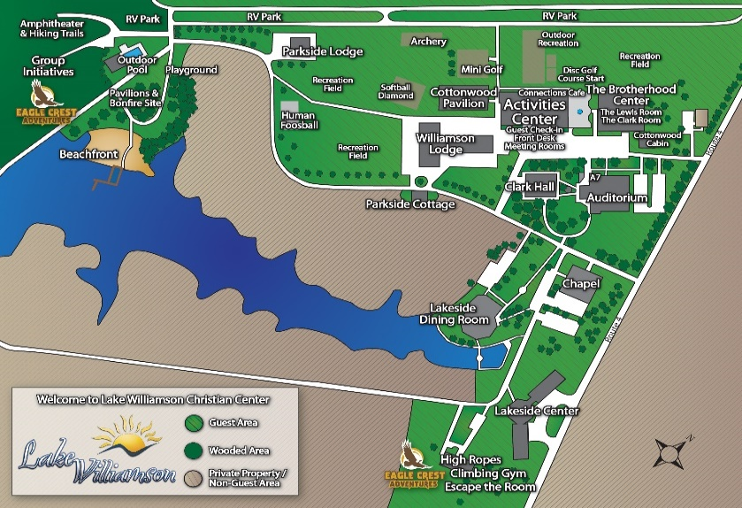 | Saturday Breakouts:  - Celebrate Recovery- Major Adam Moore  Activity Center Room 207  - God's Vision For Your Life In Christ (English)- Oscar Roan  Auditorium  3. God's Vision For Your Life In Christ (Spanish)- Major Joaquin Rangel  Activity Center Room 204  - Healthy Men's Ministries- Phil Hull  Activity Center Room 201  Sunday Groups By Division:  Eastern Michigan WMNI CFOT  Heartland Midland WUM  Indiana Northern Metropolitan  KWM Western  Midland  Northern  Western  WMNI  WUM  ARC  CFOT

